EXPNO 12:CREATE A CLONING OF A VM AND TEST IT BY LOADING THE PREVIOUS VERSION/CLONED VM.
DATE:19.11.2025
AIM:
To create a cloning of a vm and test it by loading the previous version/cloned vm.
PROCEDURE:
STEP 1: GO TO VM AND GOTO MANAGE AND CLICK CLONE
STEP 2: CLICK CLONE
STEP 3: SELECT THE FULL CLONE
STEP 4: AFTER CLONE AGAIN OR VM IS OPENED.

IMPLEMENTATION:

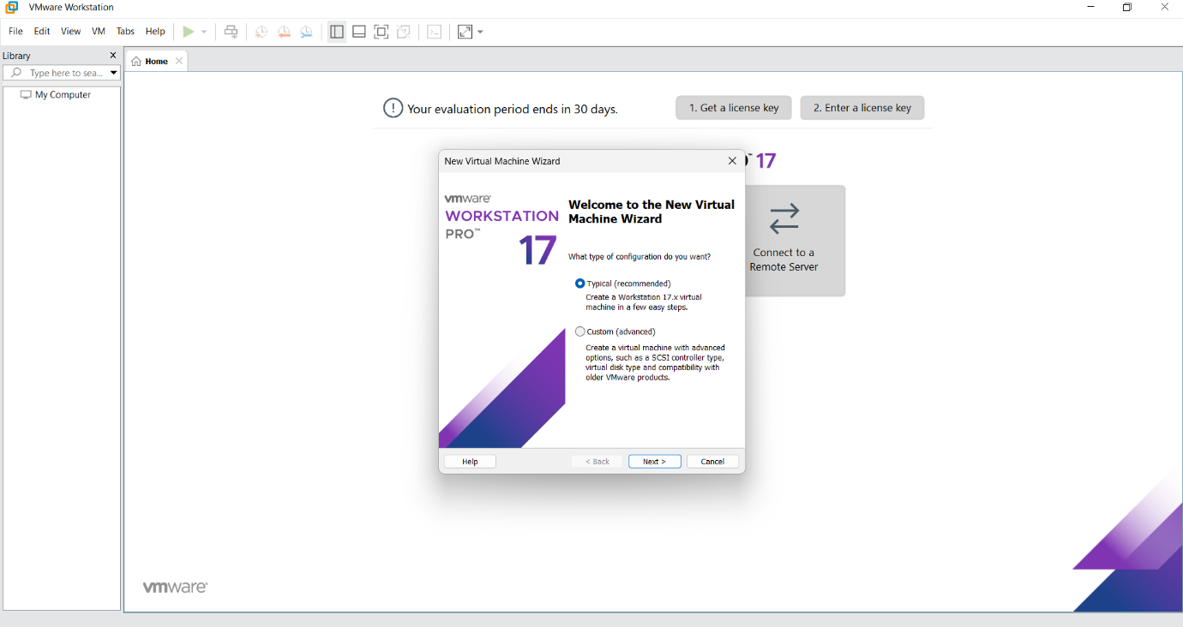

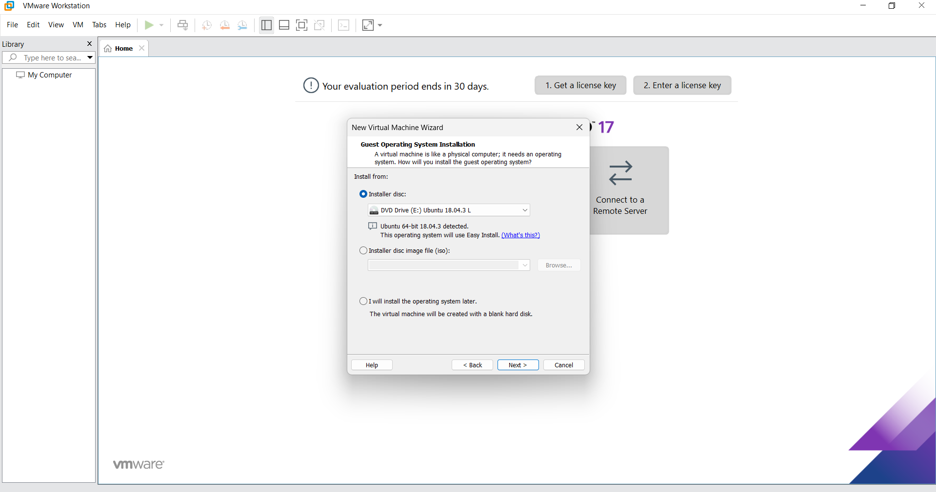

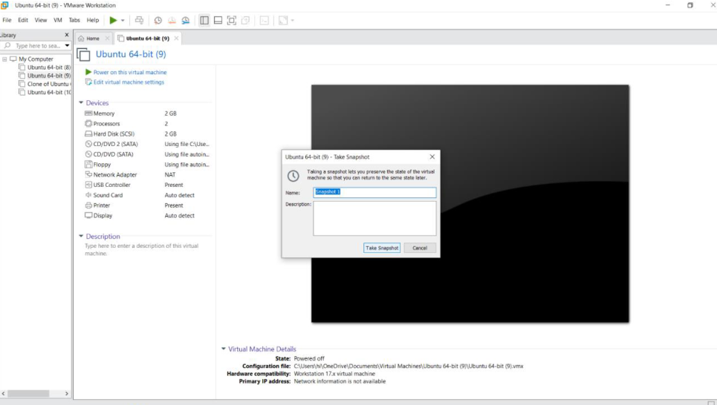

Result:
A cloning of a vm and test it by loading the previous version/cloned vm has been created.

